Guidance on the use of face masks and coverings in hospital settings to prevent COVID-19 transmission

Communications Toolkit

Introduction
On Friday, 5th June 2020, the Secretary of State for Health and Social Care announced that from Monday, 15th June 2020 all staff in hospitals in England must wear face masks, and all visitors and outpatients must wear face coverings while in the hospital setting, to reduce the risk of transmission in hospitals (nosocomial transmission).
The new Government measures set out the infection prevention and control (IPC) procedures that all NHS Trusts (acute, mental health and community) and private hospital providers must implement by the 15th June, namely:
- Hospitals should ensure that measures are in place so that all settings are, where practicable, COVID-secure, using social distancing, optimal hand hygiene, frequent surface decontamination, ventilation and other measures where appropriate.

- In all settings that are unable to be delivered as COVID-19 secure, all hospital staff (both in clinical and non-clinical roles), when not otherwise required to use personal protective equipment, should wear a facemask; worn to prevent the spread of infection from the wearer.

- Visitors and outpatients to hospital settings should wear a form of face covering for the same reason i.e. to prevent the spread of infection from the wearer.

Staff should not be at work if they are symptomatic; this guidance is targeted at people who are asymptomatic or pre-symptomatic for COVID-19.
The extended use of face masks does not remove the need for other key bundles of measures to reduce the risk of transmission of COVID-19, including social/physical distancing, optimal hand hygiene, frequent surface decontamination, ventilation and other measures where appropriate. Reliance on individual (as opposed to bundles of) measures to reduce the risk of virus transmission is not sufficient.

This guidance will be reviewed as new detail/evidence on COVID-19 emerges.

Sharing information locally
As Trust communications teams you are best placed to determine how to communicate with interested parties and what is needed to support local implementation. This toolkit provides high level messages and templates to support you to do this; you can use these or develop your own communications.

The toolkit includes:
- Narrative and key messages
- Information for staff
- Staff poster
- Information for the public, patients, and visitors
- Facility posters for hospital entrances
- Template letter for patient groups
- Template letter for local stakeholders (MPs etc)
- Short form visual asset for social media / intranets
- Q&A
Information on the requirement to wear a face covering when coming to hospital for planned and outpatient care should be included in all patient communications e.g. appointment setting calls and confirmation letters. Please ensure all clinical and booking teams are appropriately briefed to include this in any communications.
Stakeholder bodies such as trade unions, royal colleges, ALBs and patient groups have been briefed by the national team.
If there are any other resources that you think you may need, please let us know.
Media interest
Any local media interest in the changes should be managed in accordance with the existing protocols for a Level 4 National Incident: locally where this can be done within agreed messaging (contained in this document), and in coordination with your regional communications team where additional advice is required, or where a story is expected to have national profile.

Narrative

The health and wellbeing of patients and staff remains the top priority for the NHS with infection prevention and control (IPC) key to how we are handling the ongoing COVID-19 pandemic in our hospitals.
Evidence has shown that people infected with COVID-19 can have very mild or no respiratory symptoms (asymptomatic) and can transmit the virus to others without knowing, so it is important that we take immediate steps to stop the spread of coronavirus in hospitals.
Following an extensive evidence review, the Scientific Advisory Group for Emergencies (SAGE) has made recommendations on the extended use of face masks by NHS staff in hospitals, as well as the use of face coverings by visitors.
These recommendations ensure that all staff in clinical and non-clinical roles wear face masks at all times when not in places that already require PPE. This includes areas which are staff only, as well as public areas.
Visitors and patients coming to hospital for planned and outpatient care will also need to wear face coverings when in hospitals to further reduce risk. Face coverings can be made of cloth and be reusable in line with government guidance on the use on public transport.
These recommendations are in addition to existing national COVID-19 IPC guidance which advises on appropriate PPE usage in patient facing clinical settings and other measures to be taken to reduce transmission risk such as hand hygiene and social distancing.
These new measures for staff and patients will further help to reduce the risk of transmission of COVID-19 in hospital settings.

Key messages
- Reducing the risk of nosocomial transmission - Evidence has shown that those infected with COVID-19 can have very mild or no respiratory symptoms (asymptomatic) and can transmit the virus to others without being aware of it. This guidance aims to reduce risks of transmission from people who are asymptomatic or pre-symptomatic for COVID-19.
- Staff play an important role in preventing transmission in hospitals: It is important that we take steps to reduce the risk of transmission by asking all staff (clinical and non-clinical) to wear masks at all times.
- Help us help you stay safe in hospital – When you come to hospital for planned and outpatient care as a visitor, you will need to wear a face covering. By doing so you are helping to reduce the risk of spreading coronavirus and keeping our hospitals safe.

Staff information
New infection prevention and control (IPC) measures on the use of face masks to help prevent the spread of COVID-19 infection in hospitals were announced by the Secretary of State for Health and Social Care on 5th June 2020.
Evidence has shown that people infected with COVID-19 can have very mild or no respiratory symptoms (asymptomatic) and can transmit the virus to others without being aware, so it is important that we take steps to reduce the risk of transmission.
What does this mean for staff?
The guidance advises that in all settings that are not COVID-19 secure, all hospital staff including clinical (medical, nursing, allied health, diagnostics etc) and non-clinical (administration, porters, volunteers, cleaning, estates staff, contactors working on NHS sites etc), must wear a type I or type II face mask at all times when not otherwise required to use PPE to prevent the spread of infection from the wearer.
Type IR and IIR masks have an extra layer of material that ensures splash resistance and are not required for this purpose, but they can be used in place of Type I or II masks if needed. You will be advised if you should use a type IIR mask. Face coverings, as required for visitors and outpatients, are not considered acceptable substitutes for staff.
When eating or drinking, you should maintain social distancing rules and remove your mask, dispose as offensive waste, and wash your hands for 20 seconds/use alcohol hand rub to sanitise your hands prior to eating. Do not place the face mask on dining tables or nearby surfaces. Once you have finished eating/drinking, you should sanitise your hands again and put on a new facemask to return to workplace. Secure supplies of facemasks and alcohol hand rub will be made available in staff canteen areas.
If you are working alone you will not be expected to wear a mask, but when you leave your private work area or move through the hospital building e.g. on an errand, or for meal breaks, you will need to put on a surgical face mask. If you share a workspace with others, you must still wear a surgical facemask unless a formal risk assessment has been carried out and you are advised this is not necessary.
At the end of your shift you should again dispose of the face mask as offensive waste and sanitise your hands before leaving.
If you have a long term health problem, difficulties breathing, or severe claustrophobia, please discuss this with your line manager and occupational health department who will provide individual advice.
Usage of the appropriate level of personal protective equipment (PPE) in line with the latest guidance from Public Health England must continue in patient facing clinical roles.
A strong focus on excellence in infection prevention and control (IPC) at [insert trust name] is critical. Wearing a mask does not remove the need for other key IPC measures and you should continue to follow procedures including social/physical distancing, optimal hand hygiene, frequent surface decontamination, ventilation, and other measures where appropriate. Reliance on singular measures to reduce the risk of virus transmission is not sufficient.

More information on national IPC guidance can be found on the Public Health England website. You can find more information on what we are doing locally and access guides and materials at [insert method i.e. on the intranet with link, IPC lead with details etc.]
Information for patients
The guidance also recommends that all visitors and patients coming to hospital for planned care (outpatients) wear face coverings at all times.
Face coverings are different to face masks in that they can be homemade, made of cloth, and be reusable. If a patient or visitor does not have a face covering when they come to hospital, a face covering or mask will be provided by the hospital on arrival.
Patient information on the changes being implemented across the Trust will be made available and communicated to our patient forums. New facility posters will also be posted at all entrances to the hospital to advise of the requirement for a face covering to be worn.
It’s important that we continue to communicate clearly and consistently with patients – both to reassure them that everything is being done for their safety, and so they understand what they need to do when they are coming to hospital.
When booking patients to come to hospital for planned care (outpatients), it is important that the requirements for a face covering are clearly explained during the booking and confirmation process. A standard paragraph on how to communicate this can be found at [link to local intranet or insert copy here].
A guide with communication tactics for patients and visitors who are deaf or have a hearing impairment and may be impacted by staff wearing masks can also be found at [link – infographic and info available in FAQs for local adaption].
Where do I go for more information?
If you have further questions on our local plans to reduce the transmission of COVID-19 within the Trust, [insert method here i.e. intranet page, local contact].
The Guidance on the use of face masks and coverings in hospital settings to prevent COVID-19 transmission is published at [add link].

Staff poster
The below staff poster has been developed in line with the guidance for use in staff areas such as canteens, offices, nursing desks etc. A high resolution version is available on the Campaign Resource Centre.
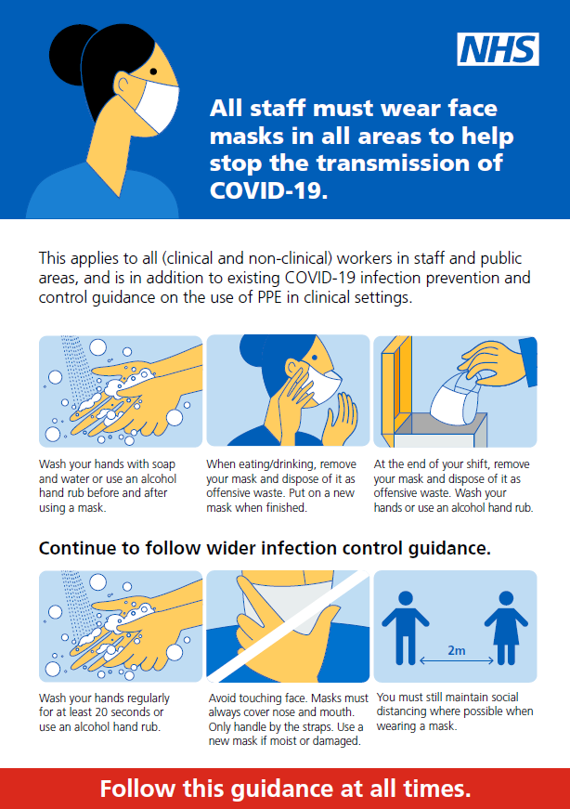
Patient information
The use of face coverings when coming to hospital at [Trust name]
People infected with COVID-19 can have very mild or no respiratory symptoms (asymptomatic) and can transmit the virus to others without being aware of it.
In line with recent recommendations from the World Health Organisation, we are introducing new measures at [trust name] to keep visitors, patients, and staff safe.
From Monday, 15th June 2020 you will need to wear a face covering when you come to hospital as a visitor or outpatient.
What does this mean for me?
We can all play a role in reducing the spread of coronavirus and keeping our hospitals safe. If you are coming to hospital as a visitor or for planned outpatient care, it is important that you wear a face covering at all times. This is for your safety and the safety of other patients and staff.
Face coverings can be cloth and/or homemade, and advice on how to wear and make one can be found on the government website. Face coverings worn as part of religious beliefs or cultural practice are also acceptable, providing they are not loose and cover the mouth and nose.
We are asking that you plan in advance and bring a face covering with you whenever possible, but if you do not have one available when you come to hospital, please see a member of staff on arrival and we will provide you with one.
If you are currently shielding and have been provided with a surgical face mask for your appointments, please continue to use this. If you have not been provided with a surgical face mask, you should wear a face covering.
For some people, wearing a face covering may be difficult due to physical or mental health conditions. In these instances, other measures will be considered on a case by case basis, for example timed appointments and being seen immediately on arrival.
If you are a deaf or hearing impaired, our staff have a range of communication options to ensure that they can communicate effectively with you. This might include the use of clear masks where possible, as well as visual aids such as writing things down, speech to text apps and sign language.
All visitors will be expected to comply with existing social distancing and hand hygiene measures in addition to the face coverings while in the hospital setting.
Where do I go for more information?
If you have further questions regarding the changes we have made across the Trust, please [insert method here i.e. please ask a member of staff/please contact].

Template facility poster – patients and visitors
The below staff poster has been developed in line with the guidance for use at all entrances to hospital facilities. A high resolution version is available on the Campaign Resource Centre.
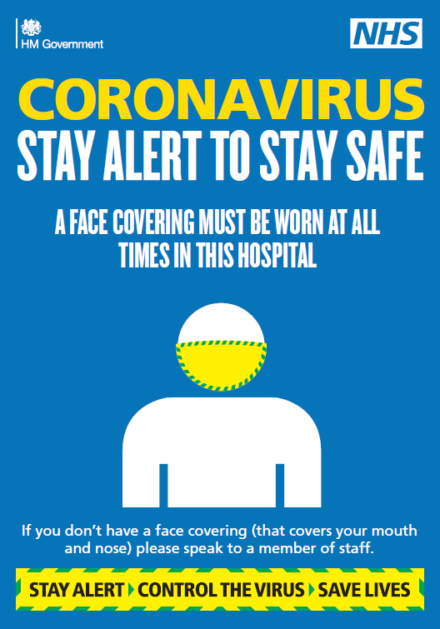

Patient Groups - Letter to patient forums

Dear [insert group name],
Following recent announcements by the Secretary of State for Health and Social Care, from Monday, 15th June 2020 [trust name] will be implementing new measures on the use of face masks and coverings in hospital.
As part of the measures, visitors and patients coming to hospital for planned and outpatient care will need to wear face coverings when in the hospital setting to reduce the risk of spreading coronavirus to other patients and staff.
Face coverings can be made of cloth and be reusable in line with government guidance on the use of face coverings for public transport. Face coverings worn as part of religious beliefs or cultural practice are also acceptable, providing they are not loose and cover the mouth and nose.
People who do not bring a face covering with them when attending hospital will be provided with one by the trust. Some patients who are currently shielding have also been provided with a surgical facemask for necessary in-person appointments.
Wearing a face covering may be difficult for some people due to physical or mental health conditions. In these instances, other measures will be considered on a case by case basis, for example, timed appointments and being seen immediately on arrival.
We understand that the use of face masks by clinical staff can be challenging for patients who are deaf or hearing impaired. Where possible, clear masks will be used by clinical staff to communicate with these patients, or alternative communication techniques employed such as the use of visual aids like writing things down, speech to text apps, and sign language.
All staff in clinical and non-clinical roles will also wear face masks when not in clinical environments that require PPE as part of the new measures, including staff only and public areas.
These recommendations have been made in addition to existing national COVID-19 IPC guidance and other measures to reduce transmission risk such as hand hygiene and social distancing.
Patient and staff safety continues to be our number one priority. We believe these measures for staff and patients will help to reduce the risk of nosocomial transmission of COVID-19.
Please don’t hesitate to get in touch with if you have any questions.
[add signature(s)] – from usual relationship holder

Stakeholders – Letter to key local stakeholders and MPs
Dear xxx,
New measures to introduce face masks and coverings in [trust name] hospitals
Following recent announcements by the Secretary of State for Health and Social Care, from Monday, 15th June 2020 [trust name] will be implementing new measures on the use of face masks and coverings in hospital.

The health and wellbeing of patients and staff is the top priority of the NHS response to the coronavirus pandemic. Evidence has shown that people infected with COVID-19 can have very mild or no respiratory symptoms (asymptomatic) and can transmit the virus to others without being aware of it, so it is important that we take immediate steps to stop the spread of coronavirus by asymptotic individuals in hospitals (nosocomial transmission).
Staff measures
The guidance advises that all hospital staff, including clinical (medical, nursing, allied health, diagnostics) and non-clinical (administration, on-site contractors, porters, volunteers, cleaning, catering), must wear a type I or type II face mask (or type IIR if more available) at all times when not otherwise required to use PPE.
Supplies of facemasks and alcohol hand rub will be made available to staff to ensure appropriate supplies are accessible at all times.
Infection prevention and control (IPC) is a priority at [insert trust name] and all staff will be expected to continue to follow other IPC procedures such as social distancing, good hand and respiratory hygiene, declaring all COVID-like symptoms, and cleaning shared equipment.
Patient measures
Visitors and patients coming to hospital for planned and outpatient care will need to wear face coverings to further reduce the risk of spreading coronavirus to other patients and staff.
Face coverings can be made of cloth and be reusable in line with government guidance on the use of face coverings for public transport. Face coverings worn as part of religious beliefs or cultural practice are also acceptable, providing they are not loose and cover the mouth and nose.
People who do not bring a face covering with them when attending hospital will be provided with one by the trust. Some patients who are currently shielding have also been provided with a surgical facemask for necessary in-person appointments.
Wearing a face covering may be difficult for some people due to physical or mental health conditions. In these instances, other measures will be considered on a case by case basis, for example timed appointments and being seen immediately on arrival.
We understand that the use of face masks by clinical staff can be challenging for patients who are deaf or hearing impaired. Where possible, clear masks will be used by clinical staff to communicate with these patients, or alternative communication techniques employed such as the use of visual aids like writing things down, speech to text apps, and sign language.
We believe that these measures for staff and patients will help to reduce the risk of transmission of COVID-19 in [insert trust name]. Patient and staff safety continue to be our number one priority.
We appreciate how important it is to keep you informed of these changes. I would be happy to arrange a call with you and discuss further.
[add signature(s)] - Suggest CE and/or Medical Director

Other assets
Infographics explaining the new measures for staff and patients/visitors has been developed for use on social media, intranets etc. The below graphics are available in high resolution on the Campaign Resource Centre.
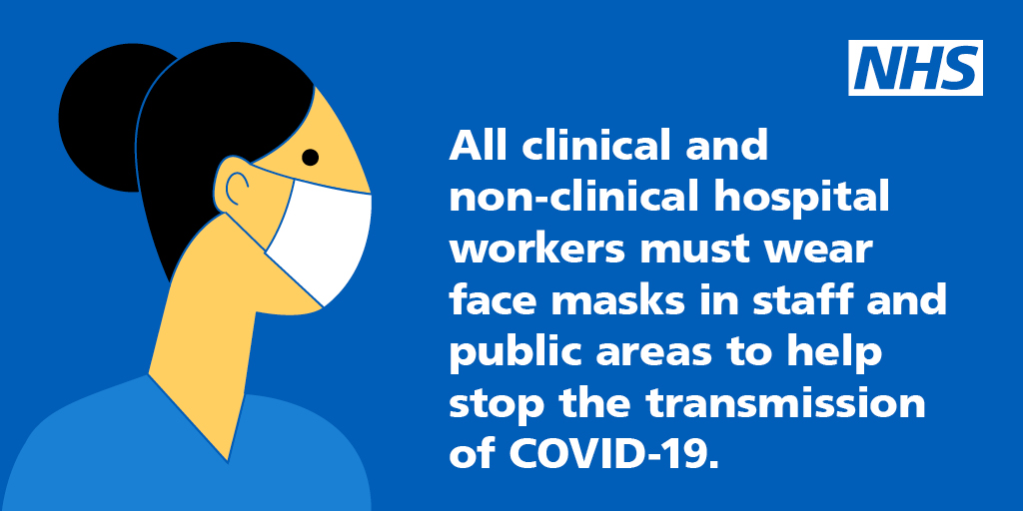
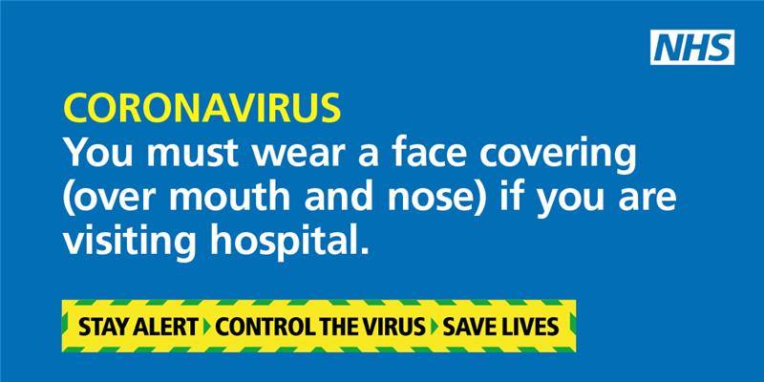

FAQs
General
Who do the recommendations apply to?
The recommendations apply to everyone working or visiting in a hospital setting.
The use of a surgical face mask applies for all staff when not in patient-facing clinical settings (where appropriate personal protective equipment (PPE) should be used in line with published guidance), including:
- clinical (medical, nursing, allied health, diagnostics etc) and
- non-clinical staff (administration, porters, volunteers, cleaning, estates staff, contactors working on NHS sites, etc).
The use of face coverings applies to all members of the public when in hospital, including those visiting patients or attending outpatient appointments.
This guidance does not cover the use of masks for inpatients nor the use of masks as personal protective equipment. This should be managed in accordance with existing guidance.
What is the difference between a face mask and a face covering?
All surgical face masks are classified as either Type I, IR, II, IIR, and are medical devices provided by the hospital.
Face coverings can be cloth or homemade and should cover the nose and mouth of the wearer.
What supplies of face masks will be made available?
Surgical face masks will be made available through hospitals’ usual PPE deliveries. Since Sunday, 7 June 2020 a larger quantity of surgical masks have been sent out each day to help hospitals prepare for the additional need. Initially extra deliveries have focused on type IIR masks, and type Is and IIs will also be delivered and will be clearly labelled so staff do not use these in clinical settings.

Staff
Why is a recommendation now being made for all hospital staff to wear a surgical face mask (Type I or II) in non-clinical and social areas?
The recommendations have been made for all staff to help prevent the spread of infection. Evidence has shown that those infected with COVID-19 can have very mild or no respiratory symptoms (asymptomatic) and potentially transmit the virus to others without being aware of it, so it is important we take steps to reduce the risk of transmission from staff who may be asymptomatic.
A face mask worn in this context will help to reduce the risk of directly transmitting SARS-CoV-2 from the wearer to others and indirectly transmitting the virus to others from contaminated environmental surfaces.
What do the different surgical face mask types mean?
All surgical/medical face masks are classified as Type I, IR, II, IIR, and are medical devices. These are tested against BS EN 14683:2019. The tests check the bacterial filtration of the mask, the breathing resistance and the splash resistance. Type IR and Type IIR have an extra layer of material that ensures splash resistance and are not required for this purpose (but could be used in place of Type I or II masks as needed). Face coverings are not considered acceptable substitutes for staff.
Why are there different characteristic of surgical face masks?
- Manufacturers produced surgical masks in a variety of colours and the external layer can be white, green, blue.
- Masks can have ear loops or head ties to secure in place.
- The masks can be made of 2, 3 or 4 layers of material.
NB: All surgical masks have external pleats/vents, and these should always be worn downwards to the outside with the nose mould used to seal the material securely around the face.
Surgical face masks should cover both nose and mouth; not be allowed to dangle around the neck; not be touched once put on – only handle by the straps when putting on and taking off; and be changed when they become moist or damaged.
Do I need to wear a mask if I work in a private workspace where I work alone?
No, if you are working alone you will not be expected to wear a mask but when you leave the private work area to move through the hospital building, e.g. on an errand, or for meal breaks, you should put on a surgical face mask (Type I or II).
If you share an office with others, hospitals can perform specific (e.g. office or laboratory) workplace assessments. If these demonstrate robust and reliable COVID-19 prevention measures, including but not necessarily limited to social/physical distancing, hand hygiene and frequent surface and equipment decontamination, then face masks for staff may not be needed. All risk assessments that conclude that areas are COVID-secure should be documented.
What if I am already wearing a face mask for sessional use, do I need to change my mask?
Yes, if you are leaving a clinical area. This is because you have been wearing a mask to protect yourself when providing direct patient care. This should be removed when you leave the clinical area; and hand hygiene performed, prior to putting on a Type l or Type ll face mask.
What happens when I go to the hospital restaurant/staff room wearing my face mask?
You should continue to maintain social/physical distancing measures while in hospital restaurants or staff rooms. If eating/drinking, you should remove your mask and dispose as offensive waste. Do not place the face mask on dining tables or nearby surfaces. Once you have finished eating/drinking you should put on a new face mask to return to your clinical area or workplace. Secure supplies of face masks and alcohol hand rub should be made available in staff canteen areas.
At the end of the shift/day you should dispose of the face mask: you may use more than one mask depending on the duration of your shift.
How will staff have access to face masks when they arrive for work?
A supply of masks should be made available to staff as they arrive on the premises as near to staff entrances as possible (eg held at staffed reception desks). Handwashing or alcohol hand rubs should be available prior to donning (putting on). These area(s) should be large enough to accommodate several staff members to ensure physical distancing is maintained.
If, for example, staff are on-call and are required to work at various times, then they should be given a mask prior to leaving work.
Each organisation will need to identify a safe and secure method of supply. Face masks must be stored in accordance with manufacturers’ guidance.
How do I dispose of my face mask after work?
Each organisation will need to provide offensive waste bins and alcohol hand rub at facility exits to ensure that staff are able to remove masks and dispose of them and decontaminate their hands.
Will wearing a face mask in a non-clinical area protect me from getting
COVID-19?
The purpose of wearing a face mask in non-clinical areas is to prevent transmission from asymptomatic staff to others who they may come into contact with.

Symptomatic staff should be excluded from work.

Wearing a face mask is only one infection prevention and control measure that can help to limit the spread of COVID-19. Other measures include: compliance with social/physical distancing (two metres); frequent environmental cleaning; hand and respiratory hygiene.

What if I have a long-term health problem/breathing difficulties/claustrophobia and worry wearing a mask may make it worse?
Please discuss this with your line manager and occupational health department who will provide individual advice.

I work in an elective area (non-COVID) - do I need to wear a surgical face mask?
This recommendation is for all staff in all settings and areas of the hospital when not otherwise required to use personal protective equipment as per existing IPC guidance.
What does this mean for pregnant women during appointments and labour?
As inpatients, women in labour are managed under different guidance. Women in hospital setting as outpatients to antenatal or postnatal appointments will need to wear a face covering under the guidance. Children and babies under three years should not wear a covering, as per recently updated DHSC guidance.
How do I put on and take off my mask?
Local infection prevention and control teams can support training for staff who are not used to routinely wearing a face mask.
Outpatients and visitors
Why are we asking visitors/patients visiting the site to wear face coverings?
Outpatients or visitors coming to the hospital will need to wear face coverings to reduce the risk of transmitting coronavirus to others. Evidence has shown that those infected with COVID-19 can have very mild or no respiratory symptoms (asymptomatic) and potentially transmit the virus to others without being aware of it
Outpatients should be advised of the need to bring a face covering ahead of coming to hospital for planned and outpatient care (outpatient appointments etc); for example in appointment setting calls and confirmation letters.
What happens if an outpatient/visitor does not have a face covering when they come to the hospital?
If an outpatient or visitor does not have a face covering when they come to hospital, one should be provided by staff on arrival.
Local implementation plans should identify how this will be managed.
How do we communicate this new rule to visitors/outpatients?
The need for visitors/outpatients to wear a face covering when visiting the hospital site should be communicated through appointment letters, social media, local news stations/papers and through signage displayed at entrances to the site throughout wards and departments.
Staff should use any opportunity to inform patients of the rationale for face coverings. Consider using hospital volunteers to remind patients/visitors as they arrive on site. A face covering is not a medical/surgical mask. If outpatients and/or visitors do not have face coverings, the trust/hospital may need to provide surgical masks or consider having a stock of face coverings available.
A toolkit has been developed to support local communication with outpatients and visitors and will be made available to trust communications teams via regional communication channels.

What does this mean for shielding patients?
For those patients who are currently shielding, and who have been provided with a surgical face mask for their appointments, these should be worn. Where not already provided, patients should wear a face covering.
What about cloth/homemade/donated face masks?
Outpatient and visitor face coverings can be cloth and/or homemade (www.gov.uk/government/publications/how-to-wear-and-make-a-cloth-face-covering) All visitors will be expected to comply with two -metre social/physical distancing and the recommended hand hygiene measures.
Where applicable, visitors to high risk COVID-19 areas of the hospital or visitors of patients with confirmed COVID-19 must wear appropriate PPE as per the current IPC guidance https://www.gov.uk/government/publications/wuhan-novel-coronavirus-infection-prevention-and-control
Staff should comply with the guidance on wearing a surgical face mask (as appropriate when in clinical/non-clinical areas) while at work.
Does my face covering worn for religious beliefs/cultural practice qualify?
Face coverings worn as part of religious beliefs or cultural practice are acceptable, providing they are not loose and cover the mouth and nose.
What if an outpatient/visitor is unable to wear a face covering?
For some, wearing of a face covering may be difficult, and therefore all other measures must also be considered and introduced e.g. social/physical distancing, timed appointments; being seen immediately and not kept in waiting rooms. Individual risk assessments should be undertaken where required; for example, patients with mental health and learning disabilities. Such risk assessments must be documented.
What about the impact of masks on communication for people who are deaf or have a hearing impairment?
The use of face masks due to the coronavirus pandemic may have an impact on patients who are deaf or have a hearing impairment as they can block the face of healthcare workers and prevent the ability to use visual cues such as facial expressions and lip reading.
The Government's PPE procurement team has sourced an initially small number of clear surgical face masks to support communication with patients who may be deaf or hearing impaired. They are working with regions to identify where those are best distributed.
Where clear masks are not possible, the below diagram outlines some good communication tactics to consider supporting patients and visitors who are deaf or have a hearing impairment:
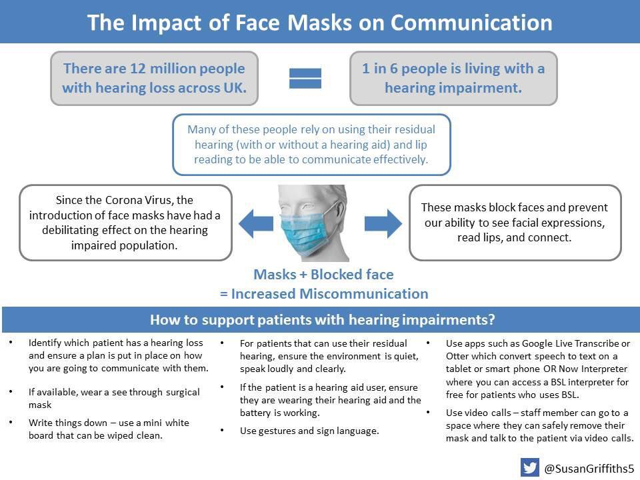

ENDS

