HIS trustee eligibility and responsibility declaration 2025
Please check the appropriate box if you agree with the following statements
By completing and signing this form, you declare that you:
Are willing to act as a trustee of the Healthcare Infection Society (HIS) and you understand HIS's purposes (objects) and rules set out in its governing document (constitution) | ☒
Understand that it's an offense under section 60(1)(b) of the Charities Act 2011 to knowingly or recklessly provide false or misleading information | ☒
Will comply with your responsibilities as trustees - these are set out in the Charity Commission guidance 'The essential trustee (CC3)' | ☒
Know your organisation’s funds are held in its name in a bank or building society account in England or Wales | ☒
Confirm the primary address and residency details you provide in a charity registration application are correct, and you will notify the Charity Commission if they change | ☒
Confirm the information you provide is true, complete and correct | ☒
Please confirm that you:
Do not have an unspent conviction for one or more of the offences listed here  https://assets.publishing.service.gov.uk/government/uploads/system/uploads/attachment_data/file/731084/010818_Disqualification_Reasons_Table_v2.pdf | ☒
Do not have an IVA, debt relief order and/or a bankruptcy order | ☒
Have not been removed as a trustee in England, Scotland or Wales (by the Charity Commission or Office of the Scottish Charity Regulator) | ☒
Have not been removed from being in the management or control of any body in Scotland (under relevant legislation) | ☒
Have not been disqualified by the Charity Commission o are a disqualified company director or are a designated person for the purposes of anti-terrorism legislation or are on the sex offenders register | ☒
Have not been found in contempt of court for making (or causing to be made) a false statement or have been found guilty of disobedience to an order or direction of the Charity Commission | ☒
Personal benefit: if HIS pays (or will pay) any trustee for being a trustee OR any trustee or person connected to them for providing goods and services, you declare that this will:
Be in the organisation’s best interests | ☒
Be lawful and authorised | ☒
Help HIS carry out its purpose (or be a necessary by-product of it carrying out its purposes) | ☒
Name: Dr Christopher Paul Bushby
Signed: 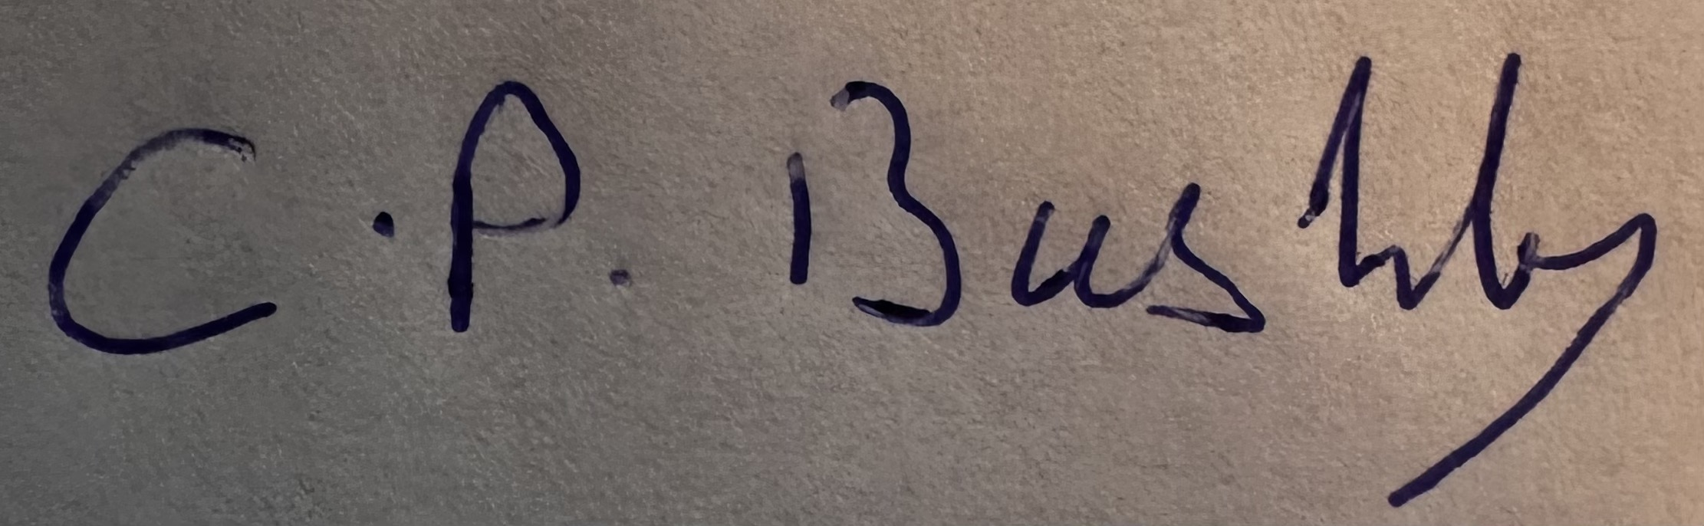 Date: 1st September 2025

